UNITING CHURCH IN AUSTRALIA

PRESBYTERY OF ILLAWARRA

ABN: 74 041 246 188

*Focused on God’s Mission – Providing Leadership – Growing Discipleship*

# GAS COMPLIANCE REQUIREMENTS

## Certificates of compliance and certificates of inspections

From 1 September 2020, Fair Trading will no longer accept mailed or emailed copies of certificates of compliance and certificates of inspection.

## Certificates of compliance and inspection

Gasfitters and autogas mechanics must provide NSW Fair Trading with a completed copy of a certificate of inspection or certificate of compliance within 5 business days following any gasfitting or autogas work.

## Certificate of inspection

Gasfitters must provide a certificate of inspection when gasfitting work is carried out on a gas installation not connected to a gas network. Within 5 business days after completing work on a non-networked gas installation the gasfitter must:

* inspect all gas containers, gas regulators and gas appliances connected to the installation
* test the whole installation for defects
* attach a compliance plate to the installation
* provide a certificate of inspection to the owner of the installation.

The gasfitter must also keep a copy of the certificate of inspection for 5 years. Certificates of inspection must be completed on the [MyInspections](https://applications.fairtrading.nsw.gov.au/MyInspections/) gateway.

## Compliance plates

Compliance plates must be in an approved form as per [clause 55(1)(a)](https://legislation.nsw.gov.au/view/html/inforce/current/sl-2018-0501#sec.55) of the Gas and Electricity (Consumer Safety) Regulation 2018. Compliance plates can be manufactured as per the approved form specified below:

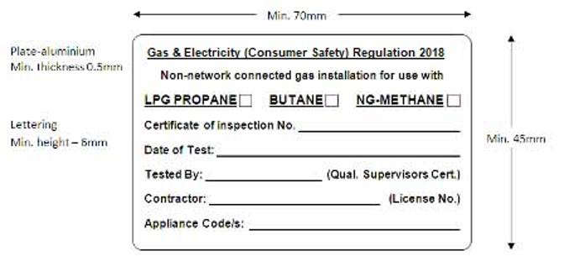

The requirements for compliance for gas installations have been updated to ensure the numbers better reflect modern appliances. The appliances are now numbered as shown in the table below.

## Gas Appliance Compliance Test Template

|  |  |  |
| --- | --- | --- |
| **Type of appliance** | **Number** | **Date Tested** |
| **Stationary engine power generator or air conditioner,** | 0 |  |
| **Cooktop or wok cooker,** | 1 |  |
| **Refrigerator or absorption chiller,** | 2 |  |
| **Instantaneous water, pool or spa heater,** | 3 |  |
| **Tank hot water heater** | 4 |  |
| **Hot plate, grill or BBQ,** | 5 |  |
| **Oven for baking, curing or drying,** | 6 |  |
| **Decorative flare or gas light,** | 7 |  |
| **Room heater or space heater** | 8 |  |
| **Other appliance** | 9 |  |

|  |  |  |
| --- | --- | --- |
|  |  |  |