From: Synod Risk Team
Sent: Friday, 20 May 2022 6:25 PM
To: Vi Richardson <Admin.ip@nswact.uca.org.au>
Subject: Testing and tagging

Here is a bit more information about testing and tagging of electrical equipment. The WHS Regulation only requires inspection and testing of equipment which is being used in a ‘hostile’ environment;

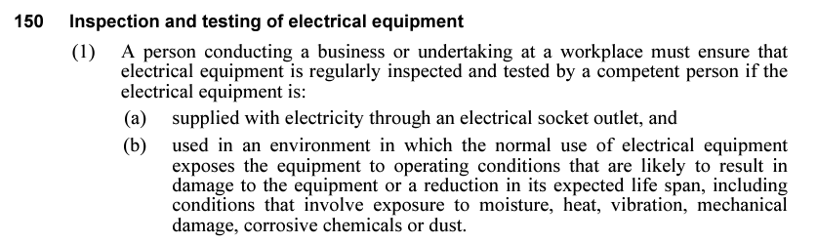

For that reason, we usually suggest that cords and electrical items are regularly visually inspected, and for many of our congregations, that could cover it unless they identify an additional need as we do have activities and ministries where the risk is higher.

The Code of Practice on managing electrical hazards recommends following the Australian Standard on Safety Inspection and Testing. This sets out expectations for best practice in this area. For most congregations, formal testing and tagging could be 5 yearly, and testing of the RCD every 6 months as per the table below (from AS/NZS 3760:2010);

